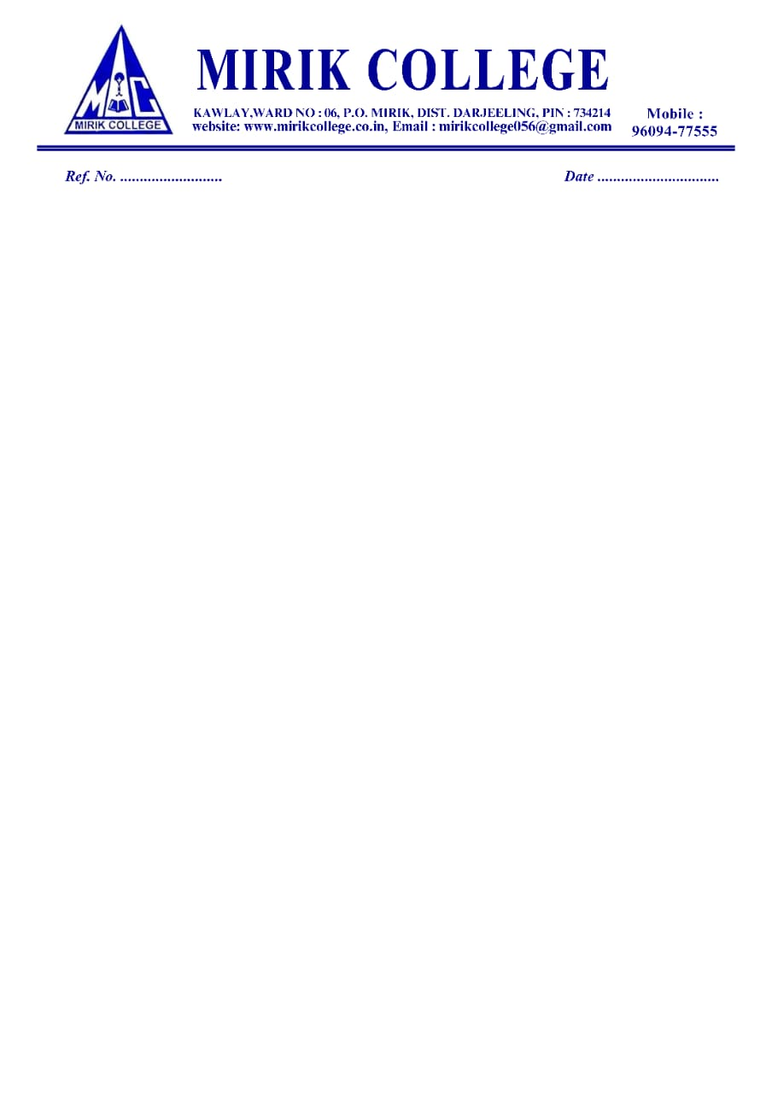

27/09/2024

DETAILS OF SUSPENDED OFFICIALS AND STAFF

Name of the Suspended Employee | Name of the Office/Institution with address | Suspended  From | Reason for Suspension | Any other details
NA | NA | NA | NA | NA

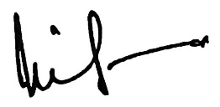

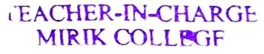
Smt. Nima Lama
Teacher – in –Charge
Mirik College

